
Lesson 10 Teacher's Key: Play It Again
001 Game Creator (Windows only) - Instructor Reference Only
VIDEO GAME CREATION

What This Lesson Teaches
001 Game Creator's actual, wiki-verified reusable-subroutine feature (Custom Event) combined with its generic key-press mechanism (Input Trigger) - both researched and confirmed against the official wiki before writing this lesson, given this engine's history of needing extra care.

Level 1 - Full Worked Solution
- Custom Event is a genuinely new concept for this course - previous lessons only ever used Actor Triggers and Input-driven scripts; this is the first reusable, callable block of logic, matching the same underlying need every other engine has this week.
- The Input Trigger for R uses the exact same mechanism (an Input Set with a Control Combination) that's been powering movement and shooting since Lesson 2 - no new input concept, just a new key bound to new logic.
- The If(game_active = 1) guard added to both existing Triggers is what actually freezes the GAME STATE (score/lives can no longer change) - it does not forcibly stop enemy Automatic Movement, which is a deliberate, documented design choice for this engine (see the Handout's Design Note).
enemy Actor Trigger: Collided with actor (revised) ->
If(game_active = 1)
Variable – Modify Value(score, Add, 10)
Variable – Modify Value(enemies_remaining, Subtract, 1)
If(enemies_remaining <= 0)
Variable – Modify Value(game_active, Set, 0)
Message Box("You Win! - Press R to Restart")
Actor – Destroy/Revive Actor(relate, Destroy)
Actor – Destroy/Revive Actor(this, Destroy)
enemy Actor Trigger: Left/Entered Camera (revised) ->
If(game_active = 1)
Variable – Modify Value(lives, Subtract, 1)
If(lives <= 0)
Variable – Modify Value(game_active, Set, 0)
Message Box("Game Over - Press R to Restart")
Actor – Destroy/Revive Actor(this, Destroy)
Input Trigger: R (Pressed) ->
If(game_active = 0)
Call Custom Event(ResetGame)
Custom Event: ResetGame ->
Variable – Modify Value(score, Set, 0)
Variable – Modify Value(lives, Set, 3)
Variable – Modify Value(enemies_remaining, Set, 5)
Variable – Modify Value(game_active, Set, 1)
Actor – Destroy/Revive Actor(enemy_1, Revive) -> Actor – Teleport(enemy_1, [starting position])
(repeat for enemy_2, enemy_3, enemy_4, enemy_5)
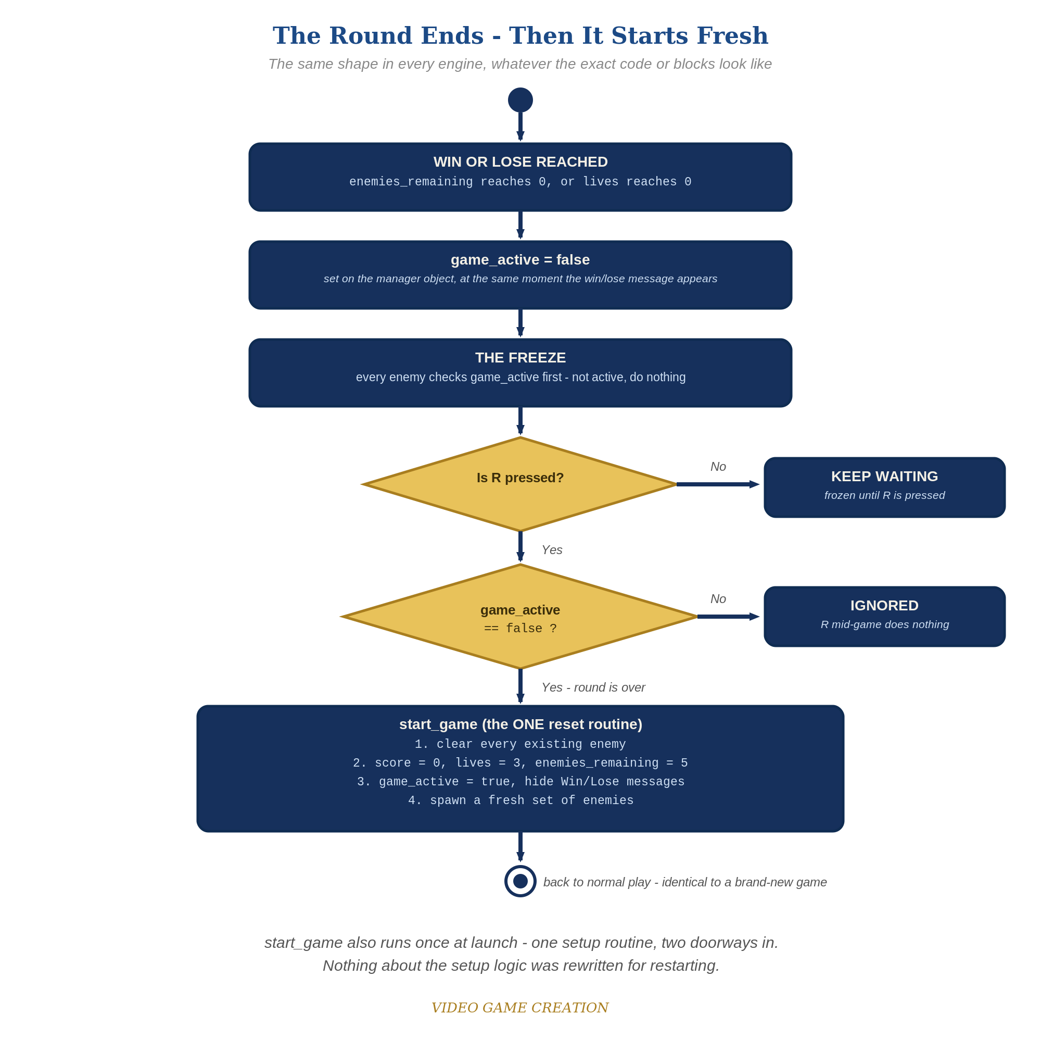
When the round ends, everything freezes - and R, pressed only while the round is over, runs the one reset routine. The same shape in every engine.

Why This Structure
- A built-in "Restart Game" action does exist in 001 Game Creator (confirmed via community documentation), but its exact reset behavior (what state it clears, what it preserves) isn't clearly documented on the official wiki - teaching the manual, verified Custom-Event approach instead is both safer and better pedagogy, since it makes every piece of the reset explicit and visible to students.
- Because Lesson 5 chose design-time placement over a runtime spawn loop for this engine, 'respawning' here means REVIVING and REPOSITIONING the same named Actor copies, not creating new ones - a direct, sensible consequence of that earlier design choice, not a new complication.

Level 2 / Level 3 Talking Points
- This is worth explicitly connecting back to Lesson 5's design-time-placement decision: ask students why 001 Game Creator's restart looks different (reviving named copies) from every other engine's (spawning new instances) - the answer traces directly back to that earlier, deliberate choice.
- If a student asks why enemies aren't forcibly stopped at game-over the way other engines freeze movement: this is a good moment to discuss that not every constraint needs a workaround - sometimes accepting a small, harmless visual imperfection (a couple of enemies finishing their slide) is the right, honest engineering call, verified-safe rather than reaching for an unconfirmed API.
Level 2 - complete code:
// Level 2 is verification only - the Level 1 code is already correct, so no lines change.
// Checks: after a win and after a loss, R restores 0/3/5 with no leftover enemies; R during play does nothing.
Level 3 - code (additions highlighted):
Highlighted lines are the Level 3 additions on top of the Level 1 code.
// Level 3 visual: add to the end of each Message Box trigger branch.
If(game_active = 0)
Camera - Fade (Fade Out, 0.5 seconds)

Common Student Mistakes
- Forgetting the If(game_active = 1) guard on one of the two Triggers, allowing score or lives to keep changing after the round has technically ended.
- Typo'd Actor names inside the ResetGame Custom Event (enemy_1 vs. Enemy_1, etc.) - 001 Game Creator won't necessarily flag this loudly, so it's worth testing that all 5 copies actually reappear.
- Setting the Input Trigger's Control Combination to "Released" instead of "Pressed," causing the restart to fire when R is let go rather than when it's first pressed down (functionally similar but worth getting consistent with the rest of the course's "Pressed" convention).

